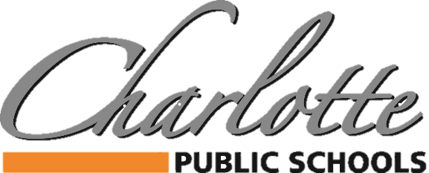

***378 State Street, Charlotte, MI 48813 PH: 517.541.5100 FAX: 517.541.5105***

BUDGET AND SALARY/COMPENSATION TRANSPARENCY REPORT

DISTRICT PAID ASSOCIATION DUES/MEMBERSHIP

2023-2024

|  |  |  |  |  |
| --- | --- | --- | --- | --- |
| ASSOCIATION | AMOUNT |  | ASSOCIATION | AMOUNT |
| BUSINESS PROFESSIONALS OF AMERICA | $662 |  | COMP CHEER COACHES OF MI | $115 |
| CAPITAL AREA ACTIVITIES CONFERENCE | $3,250 |  | MSBOA | $750 |
| CHARLOTTE CHAMBER OF COMMERCE | $700 |  | MISCA | $50 |
| CHARLOTTE ROTARY CLUB | $1,175 |  | MECA | $75 |
| HPS | $3,275 |  | MHSIBCA | $80 |
| MASB | $5,479 |  | BCAM | $82 |
| MASSP | $1,400 |  | MWA | $405 |
| MHSAA | $30 |  | INGHAM ISD | $10,986 |
| MIAAA | $155 |  | GFOA | $280 |
| MASA | $1,385 |  | CMSBO (INGHAM ISD) | $170 |
| MSBO/MAPT/ASBO | $1,815 |  |  |  |
| MIHSSCA | $60 |  |  |  |
| PROJECT LEAD THE WAY | $3,200 |  |  |  |
| MI FITNESS FOUNDATION | $102 |  |  |  |
| MAAE | $1,300 |  |  |  |
| MAASE | $300 |  |  |  |
| GREATER LANSING CVB | $125 |  |  |  |
| MEMSPA | $320 |  |  |  |
|  |  |  |  |  |

